GenericML
Human‑in‑the‑Loop AutoML + Knowledge Graphs for complex, regulated domains
UNSW Founders Pre‑Accelerator Application Pitch Deck

Founder: Alistair Rigney | Website: genericml.odoo.com

1. The one‑liner
- GenericML is a .NET/C# framework that lets domain experts and software teams build fast, explainable machine‑learning micro‑models inside real applications (not notebooks).
- It embeds Human‑in‑the‑Loop (HITL) workflows so experts can validate labels, features, and predictions—improving trust and adoption.
- It pairs structured decision models (DDD + data vectors) with a Neo4j knowledge graph to power auditable Graph‑RAG and decision support.
Core idea: make model generation cheap and repeatable so teams can iterate to true product‑market fit.

2. The problem we solve
- AI/ML initiatives stall before production because iteration is slow, integration is brittle, and domain experts can’t participate meaningfully.
- Python + MLOps pipelines add friction for .NET product teams and regulated environments.
- Model trust is missing: explainability, lineage, validation, and drift triage are often bolted on late.
- Complex domains require relational context and multi‑hop reasoning—simple text‑chunk RAG breaks down.

3. The solution: GenericML
- DDD‑aligned domain model → clean bounded contexts → better features, less leakage.
- Data Vectors: type‑safe, decision‑ready inputs (scalars + float[] time‑series/distributions + optional graph‑derived features). Data vectors can contain scalar (single value) and vector features. i.e. data vectors can be multi-dimensional. GenericML turns ML experimentation into a configuration problem rather than a re-engineering exercise. Instead of rebuilding feature pipelines every time we try a new hypothesis, we can:
- plug in new domain features (scalar or vector),
- select the target variable dynamically,
- and generate multiple candidate models quickly, while keeping everything traceable back to the domain model.

That’s why we can iterate faster and get to a useful production model sooner. AutoML micro‑models trained on CPU (fast, low infra), tuned for each bounded context and decision even on laptops.
- HITL is built in: expert validation, label refinement, error review, and continuous supervision.
- Knowledge graph backbone for entity grounding, provenance, and hybrid retrieval (Graph + Vector).
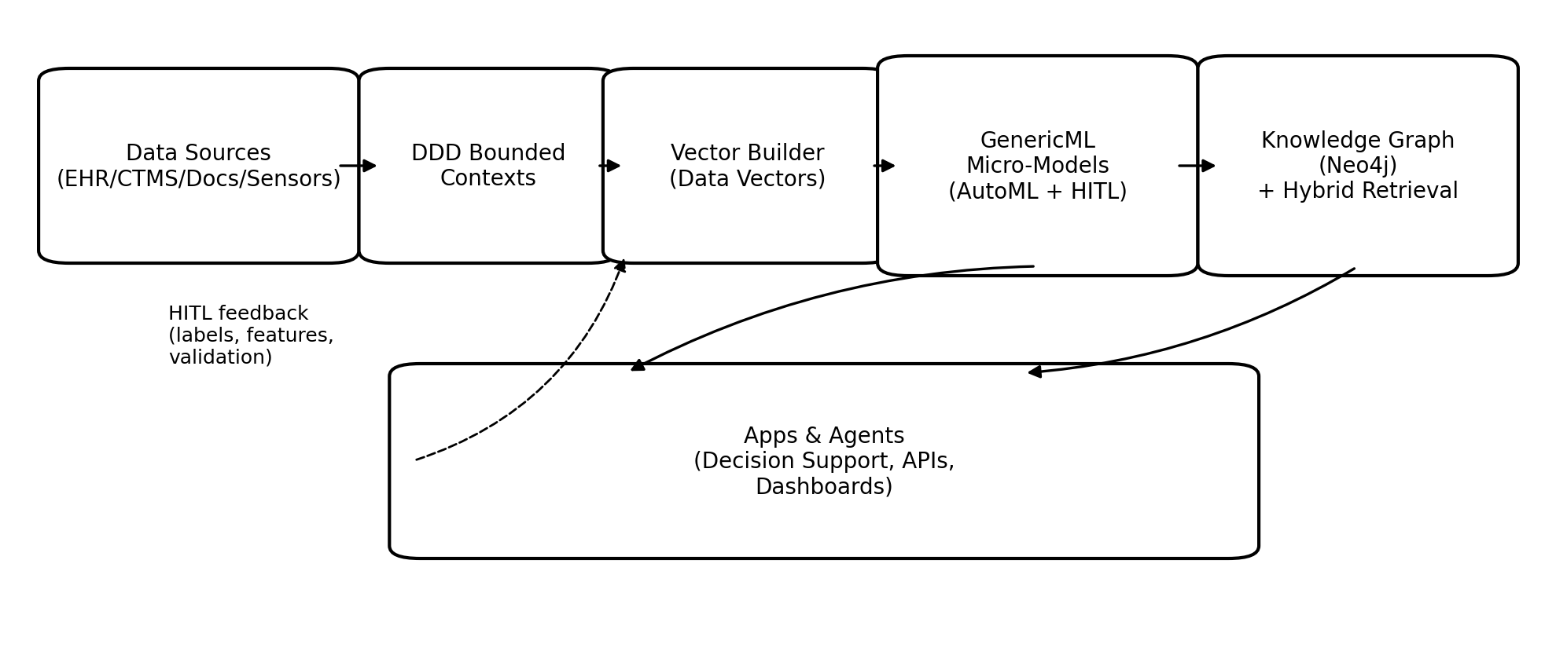
Figure: data → bounded contexts → vectors → micro‑models → knowledge graph → apps/agents, with HITL feedback.
GenericML’s advantage is not that mixed vectors are impossible elsewhere, it’s that GenericML makes them easy, repeatable, and domain-driven:
- fewer hand-built pipelines,
- fewer schema mistakes,
- faster iteration on features and labels,
- and clearer traceability from business concept → feature → model.
- And as the code is all C# its easy to ensemble models and add business code checks etc.

4. Why now, and why we’re different
- Enterprises are demanding measurable ROI from AI and moving away from “demo‑ware”.
- GenAI is accelerating interest in automation, while exposing the need for grounding, governance, and human oversight.
- GenericML optimises the organisational bottleneck (iteration + integration + trust), not just hyperparameter search.
- Designed for shipping: models are created, tested, and served within real .NET application architectures.

We are *not*:
- A notebook workflow that dies in handover.
- A platform‑only AutoML tool that ignores domain modelling and validation loops.
- A RAG‑only approach that cannot handle relational reasoning or audit needs.

5. Human‑in‑the‑Loop is structurally embedded
- Domain experts are co‑creators: feature/label choices, signal validation, anomaly interpretation.
- Explainability is non‑negotiable: inspect inputs, feature contributions, supporting comprehensive model statistics and every prediction has the reason for the prediction available.
- Fast and cheap iteration: commodity compute for many workloads; avoid GPU/platform lock‑in.
- Governance‑friendly: explicit decision models, audit trails, controlled deployment.

6. Graph‑RAG (knowledge graphs) beats simple RAG in complex domains
- Simple RAG treats knowledge as disconnected chunks—great for FAQs, weak for relational reasoning.
- Graph‑RAG grounds answers in explicit entities/relationships and supports multi‑hop questions.
- Neo4j enables hybrid retrieval: semantic search + graph traversal + provenance.

Example Graph‑RAG questions:
- “Which patient cohorts match this trial’s inclusion/exclusion criteria, and what evidence supports eligibility?”
- “Which protocols, deviations, and safety events correlate with recruitment slowdowns at specific sites?”
- “Which documents and entities support this compliance claim—and what changed since last month?”

7. Initial wedge & use cases
- Primary wedge (current traction): healthcare decision support + clinical operations intelligence.
- Starting point: Prostate cancer clinical classification / decision support MVP (doctors in Singapore).
- Adjacent wedge: TrialOps / ALERA clinical trials intelligence (site risk, recruitment forecasting, protocol deviation prediction).
- Secondary opportunities: environment & climate risk, fraud/compliance, defence/OSINT, industrial monitoring.

8. Traction so far
- Working MVP: prostate cancer model builder for doctors (Singapore).
- Customer conversations: Biocarbon (industrial) Biocarbon for carbon production for steel making. Minomic for prostate cancer applications.
- Future Wellness Group (ALERA) for applications for doctors,psychologists to manage chronically ill patients.
- Active outreach: Florey commercialisation + researchers; discussions with Prof. Murray Cairns (complex diseases) and Prof. Jeffrey Walker (near‑Earth satellite).
- Strong foundation: C# AutoML + knowledge graph + Graph‑RAG positioning; repeatable “problem → vectors → models” method.

9. Ideal customer profile (ICP) & buyer
- ICP A: clinical groups / medtechs with high‑value decisions and messy data (EHR/registries/labs/docs) needing explainability and governance.
- ICP B: research translation teams needing faster iteration and lower cost to validate models with experts in the loop.
- ICP C: regulated enterprise teams with a .NET stack where Python/MLOps overhead blocks delivery.

Buyer personas:
- Clinical/Operations lead (owns outcomes)
- Product/Engineering lead (.NET integration)
- Data/AI lead (model quality)
- Compliance/Quality lead (audit)

10. How we make money

- Paid discovery/pilot contracts (fastest path): fixed‑scope delivery for a specific decision (risk score, eligibility triage, anomaly alert).
- Subscription licensing after validation: per‑team / per‑site / per‑deployment.
- Professional services for onboarding (domain model + graph seeding + deployment templates) → then shift to subscription + support.
- Optional managed hosting for convenience; on‑prem/edge remains available.

GenericML can be extremely competitive on price as most business spend about 100-500K per model and take 6-8 months to get models into production. With GenericML due to HITL this can be done in days/weeks. Also many models can be built in parallel and Gen AI tools can be used to actually build each of the applications that domain experts can use based on previous examples.

Pricing to validate during Pre‑X:
- Pilot: AUD $15k–$50k (4–8 weeks) depending on data complexity and compliance needs.
- Subscription: AUD $1k–$5k/month per team early; expand to enterprise/site licensing after proven ROI.

14. How UNSW Founders can help (and the ask)
- Warm introductions into UNSW health, clinical trials, research translation, and relevant industry networks aligned to our wedge.
- Mentorship on narrowing ICP and converting interview insights into a priced pilot offer.
- Pitch coaching: tighten narrative to evidence, traction, and early revenue.
- Support with early healthcare compliance framing (data governance, SaMD considerations).
- Connections to co‑founders/advisors and pilot partners.

The ask:
- Accept GenericML into Pre‑X and help us run an accelerated validation sprint so we can close initial pilots quickly.

