Reference Architecture for Decision-Centric Engineering Projects

DDD-First: Domain Models, Data Vectors, Human-in-the-Loop ML (GenericML), and Knowledge Graphs

1. Purpose
This document defines a reference architecture for engineering projects that must produce durable, trustworthy outcomes in the presence of:
- complex systems and interactions,
- evolving requirements and datasets,
- analytics / ML / optimisation,
- high-stakes decisions (safety, cost, compliance, performance).
It provides a standard approach to:
- structure engineering domains,
- define decision problems explicitly,
- design reusable data vectors,
- develop and validate models with human oversight,
- ensemble model signals into decision support,
- preserve semantics, provenance, and evidence using a knowledge graph.
This architecture is domain-agnostic (process engineering, energy, civil, biomedical, aerospace, mining, etc.).

2. Problem Statement
Engineering research increasingly relies on complex data, simulation, and analytics to support high-impact decisions. However, many data-driven engineering projects fail to translate analytical results into durable, trusted, and reusable systems due to inconsistent architectures, unclear semantics, and weak links between models and decisions.
Engineering AI/analytics efforts repeatedly fail to become durable products because architecture is often:
- tool-first (pipelines/notebooks/dashboards) rather than decision-first,
- fragile under change (new sites, regimes, regulations, cohorts),
- semantically unstable (definitions drift; meaning becomes unclear),
- weak on provenance (unclear lineage: data → features → model → decision),
- difficult to audit (especially in regulated/safety contexts).
The result is slow iteration, low trust, and poor adoption.
Hence a reference architecture is proposed that uses a standardised, decision-centric research architecture combining Domain-Driven Design (DDD), human-in-the-loop machine learning (GenericML), and knowledge graphs. The approach structures complex engineering domains into bounded contexts, represents decision problems using explicit data vectors, enables rapid and transparent model experimentation, and preserves provenance and meaning through a graph-based memory layer.

3. Architectural Principles

3.1 Decision-first design
Every artefact must trace to a decision or decision-relevant workflow.

3.2 DDD semantics are authoritative
Domain meaning is captured in bounded contexts and aggregates, not in database tables or ML features.

3.3 Adaptability by extension
New requirements should be met by adding/expanding bounded contexts and aggregates, not rewriting the system.

3.4 Human authority and accountability
Humans remain responsible for thresholds, overrides, and actions. Models provide evidence, not unilateral control (unless explicitly authorised).

3.5 Provenance is a first-class requirement
Every prediction or recommendation must be traceable to:
- vector schema and values,
- model pack version,
- ensemble policy,
- evidence and validation,
- decision context and outcome.

4. Architecture Overview
The system is decomposed into:
- Domain Bounded Contexts (domain-specific, project-specific)
- A cross-cutting Decision Intelligence Bounded Context (generic)
- A Knowledge Graph Spine that integrates provenance and relationship-aware retrieval
The key move is to keep domain modelling separate from decision intelligence while maintaining controlled integration.

5. Domain Bounded Contexts (Project-Specific)

5.1 What a bounded context is in this architecture
A bounded context is a domain area with:
- its own language and semantics,
- its own invariants and rules,
- clear ownership,
- controlled interfaces to other contexts.

5.2 Typical bounded contexts in engineering (illustrative)
Your project will define its own, but common patterns include:
- Asset & Configuration (what the system is)
- Operations & Telemetry (what happens over time)
- Maintenance & Interventions (what changes it)
- Risk, Safety & Compliance (what must not be violated)
- Optimisation & Control (how we choose actions)
- Commercial / Performance Reporting (how outcomes are measured)
These are not required modules. They are examples of common bounded contexts.

6. Aggregates: The Primary DDD Unit
The architecture requires that each bounded context define a small set of aggregates (aggregate roots + invariants).
Aggregates own semantics and are the stable “objects” that survive tool changes.

6.1 Universal facets (NOT sub-domains)
Most engineering systems contain four universal facets of information:
- State (what is true now)
- Events (what happened)
- Decisions (what we chose)
- Evidence (why we chose it)
DDD-correct rule: these facets appear as:
- value objects / entities within aggregates, and/or
- separately governed aggregates when they have independent lifecycle/versioning.
They are classification lenses, not functional modules.

7. The Decision Intelligence Bounded Context (Generic)
This bounded context owns the decision-centric artefacts that span all other contexts:
- Decisions and decision logs
- Vector schemas and vector generation rules
- Vector instances (or references to them)
- Model packs (trained models with validation + envelopes)
- Ensemble policies (how multiple models combine)
- Evidence bundles (what was shown to humans)
- Outcome linkage (what happened next)
- Governance artefacts (approvals, audit trails)
Domain bounded contexts publish events and expose read interfaces; Decision Intelligence consumes and builds decision support.

8. Decision Intelligence: Aggregate Catalogue (Core)

8.1 DecisionCase (Aggregate Root)
Represents a specific decision instance (or decision episode).
Responsibilities
- Store the decision request, context snapshot, recommendations, approvals, and outcome links.
Entities / value objects inside
- DecisionType (e.g., “adjust setpoint”, “flag anomaly”, “approve intervention”)
- DecisionContextSnapshot (references to domain entities + time window)
- Recommendation (ensemble output, ranked options)
- HumanApprovalTrail (who approved, when, why)
- OutcomeRef (links to observed outcomes)
Invariants
- A decision case cannot be “finalised” without an evidence bundle reference.
- Every recommendation must reference an ensemble policy version.

8.2 VectorSchema (Aggregate Root)
Defines a reusable, versioned vector definition for a decision problem.
Contents
- SchemaId, Version
- Feature definitions: name, type (float, float[], categorical encoding), units
- Transform and normalisation rules
- Semantic hash / units hash for drift detection
- Allowed data sources (to prevent leakage)
Invariants
- A schema version is immutable once used in a model pack.
- Unit contracts must be explicit.

8.3 VectorInstance (Aggregate Root or External Reference)
Represents a concrete vector generated for a specific decision context.
Contents
- SchemaId@Version
- GeneratedAt, WindowStart, WindowEnd
- Feature values (often stored as a blob/file; graph stores reference + hashes)
- SourceEntityRefs[] (which domain entities/events contributed)
Invariants
- A vector instance must declare its provenance references.
(Implementation note: store large arrays outside the graph, keep references + hashes in graph.)

8.4 ModelPack (Aggregate Root)
A deployable model artefact with full evidence.
Contents
- Input schema reference: VectorSchemaId@Version
- Model family & hyperparameters
- Training dataset reference + snapshot hash
- Validation metrics
- Calibration artefacts (confidence, thresholds)
- Validity envelope (operating regime constraints)
- Model binary/artefact reference
Invariants
- A model pack must declare its validity envelope and evaluation evidence.
- A model pack cannot be “active” without passing a defined benchmark suite.

8.5 EnsemblePolicy (Aggregate Root)
Defines how multiple model packs combine into a single recommendation.
Contents
- Member models: ModelPackRef[]
- Combination rule: weighted average, stacked meta-model, rule-based, etc.
- Gating rules: regime-based, confidence-based, context-based
- Fallback behaviour when out-of-envelope
- Audit policy: “what must be logged”
Invariants
- Ensemble decisions must be reproducible from referenced model versions.
- Every combination/gating rule must be explicit and testable.

8.6 EvidenceBundle (Aggregate Root)
Represents what the system presented as evidence at decision time.
Contents
- Model outputs (scores, probabilities, intervals)
- Explanations (feature contributions or rationale)
- Uncertainty bounds / confidence
- Human notes, overrides, approvals
- Links to source vectors and model packs
Invariants
- Evidence bundle is immutable once used in a finalised decision case.

8.7 OutcomeRecord (Aggregate Root)
Captures what happened after the decision.
Contents
- Outcome metrics (domain-specific)
- Time window of observation
- “Counterfactual proxies” (where available)
- Link back to decision case(s)
Invariants
- Outcome must reference measurement provenance.

9. Problem Classes and How Aggregates Support Them
This section is where the architecture becomes usable for project planning.

9.1 Problem class: Similarity & benchmarking
Used when: “show me past systems similar to this one.”
Primary aggregates: VectorSchema, VectorInstance, KnowledgeGraph
Vectors: state + regime vectors; optional graph-derived similarity features

9.2 Problem class: Anomaly / change / spike detection
Primary aggregates: VectorSchema, ModelPack, EvidenceBundle, OutcomeRecord
Vectors: temporal (float[]) + regime; event-augmented where useful

9.3 Problem class: Risk scoring
Primary aggregates: DecisionCase, EnsemblePolicy, EvidenceBundle
Vectors: state + temporal + event + regime (composite)

9.4 Problem class: Forecasting
Primary aggregates: ModelPack, OutcomeRecord
Vectors: state + temporal + regime; optional graph-derived history

9.5 Problem class: Root cause analysis
Primary aggregates: EvidenceBundle + graph reasoning
Vectors: state + temporal + events + regime
KG role: multi-hop relationship reasoning for ranked hypotheses

9.6 Problem class: Optimisation / control / recommendation
Primary aggregates: DecisionCase, EnsemblePolicy, EvidenceBundle
Vectors: decision context vectors + constraints vector; regime gating required

10. Data Vectors: Reuse Without Feature Churn

10.1 Canonical vector types
- State vector: configuration, static properties, environment
- Temporal vector (float[]): time-windowed signals and trends
- Event-augmented vector: state + events in a window
- Regime vector: phase/operating regime/load indicators

10.2 Vector reuse matrix (guidance, not a mandate)
Problem class | State | Temporal | Events | Regime
Similarity | ✓ |  |  | ✓
Anomaly |  | ✓ |  | ✓
Change/Spike |  | ✓ |  | ✓
Risk scoring | ✓ | ✓ | ✓ | ✓
Forecasting | ✓ | ✓ |  | ✓
Root cause | ✓ | ✓ | ✓ | ✓
Optimisation | ✓ |  |  | ✓
Key rule: prefer reusing existing schemas; add features by versioning schemas, not by ad hoc edits.

11. GenericML: Human-in-the-Loop Model Development
GenericML is the implementation pattern for the Model & Evidence lifecycle:

11.1 Workflow
- Domain experts define a DecisionCase type and target outcome(s)
- Define/extend VectorSchema (units + semantics locked)
- Generate VectorInstances with provenance
- Train candidate models → register as ModelPacks
- Validate → publish evidence and envelopes
- Define EnsemblePolicy (human-understandable)
- Produce EvidenceBundles per decision
- Capture OutcomeRecords → feedback loop

11.2 Model families (typical)
- classification, regression
- anomaly / change / spike detection
- robust/quantile outputs for uncertainty

11.3 Ensembling types
- Weighted voting/averaging
- Stacking (meta-learner)
- Mixture-of-experts (regime-gated)
- Confidence-aware blending
- Policy stack (rule + model + thresholds)

12. Knowledge Graph Spine (Neo4j): Provenance, Retrieval, and Reasoning

12.1 Role
The knowledge graph provides:
- relationship-aware queries (multi-hop),
- semantic integration across bounded contexts,
- lineage: data → vector → model → ensemble → evidence → decision → outcome,
- schema evolution without destabilising domain contexts.

12.2 Graph node types (reference)
- Domain entities (assets, components, configurations, events)
- Decision Intelligence entities:
  - DecisionCase, VectorSchema, VectorInstance
  - ModelPack, EnsemblePolicy, EvidenceBundle, OutcomeRecord
- Governance entities (approvals, policies, benchmark suites)

12.3 Graph edges (reference)
- provenance: (:VectorInstance)-[:DERIVED_FROM]->(:DomainEntity|:Event)
- training: (:ModelPack)-[:TRAINED_ON]->(:DatasetSnapshot)
- usage: (:EvidenceBundle)-[:USED_MODEL]->(:ModelPack)
- decision: (:DecisionCase)-[:SUPPORTED_BY]->(:EvidenceBundle)
- outcome: (:OutcomeRecord)-[:RESULT_OF]->(:DecisionCase)

13. Governance, Change, and Stability Rules

13.1 Semantic stability
- Vector schemas are versioned and immutable once used in active model packs.
- KPI definitions and units have explicit contracts and hashes.

13.2 Adaptation
- New requirements → add new decision types, schema versions, or bounded contexts.
- Never “just add a column” without updating schema/version.

13.3 Auditability
For any decision case, the system must be able to answer:
- What was decided?
- What data and vectors were used?
- Which model pack versions?
- Which ensemble policy?
- What evidence and uncertainty?
- Who approved/overrode?
- What outcome followed?

14. Implementation Guidance (Minimal to Scalable)

14.1 Minimal viable architecture (MVA)
Start with:
- 1 bounded context (highest-value domain area)
- 1 decision type (DecisionCase)
- 1 vector schema
- 1–3 model packs
- a simple ensemble policy
- evidence bundles logged in the graph

14.2 Scale-up path
Add:
- more decision types,
- more contexts,
- regime gating + envelopes,
- richer knowledge graph entity coverage,
- automated query generation and retrieval workflows.

Appendices (Template)

Appendix A — Vector Schema Template
- SchemaId, Version
- DecisionType linkage
- Feature list (name, type, units, transform)
- Windowing rules for float[]
- Leakage controls
- Semantic hash & units hash

Appendix B — Ensemble Policy Template
- Member model packs
- Combination rule
- Gating rule
- Fallback behaviour
- Audit policy

Appendix C — Sample Neo4j Query Patterns
- similarity retrieval
- provenance trace
- best model pack per regime
- decision outcome comparison

Appendix D — Text-to-Cypher Patterns
- controlled templates: “find similar”, “trace provenance”, “compare cohorts”
- graph-safe prompting: restrict labels/relationships; parameterised queries

Appendix E. Diagrams

Context Map Diagram: Domain Contexts ↔ Decision Intelligence ↔ KG Spine
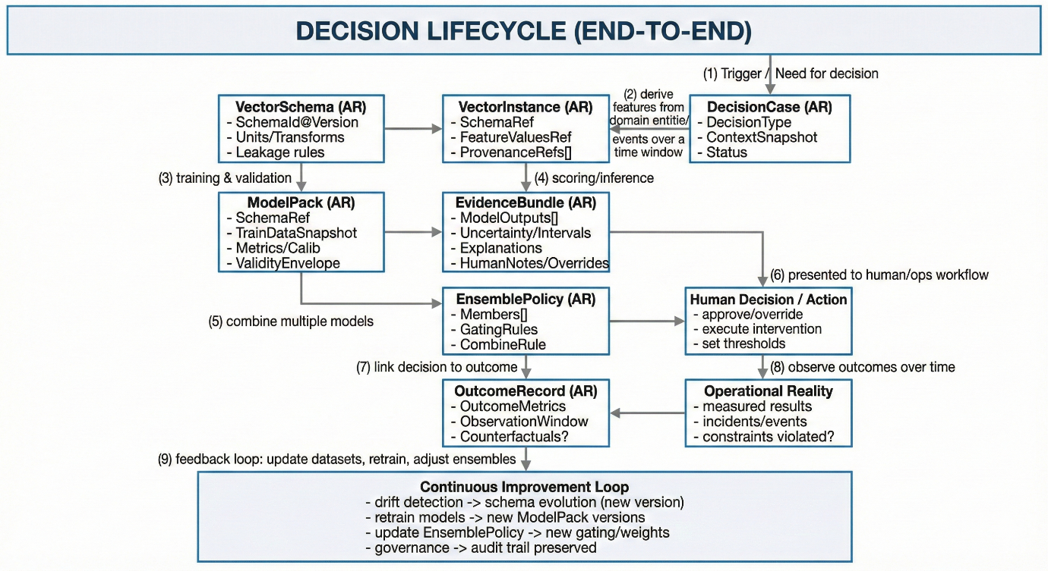

Lifecycle Diagram: DecisionCase → VectorInstance → ModelPack → EnsemblePolicy → EvidenceBundle → OutcomeRecord
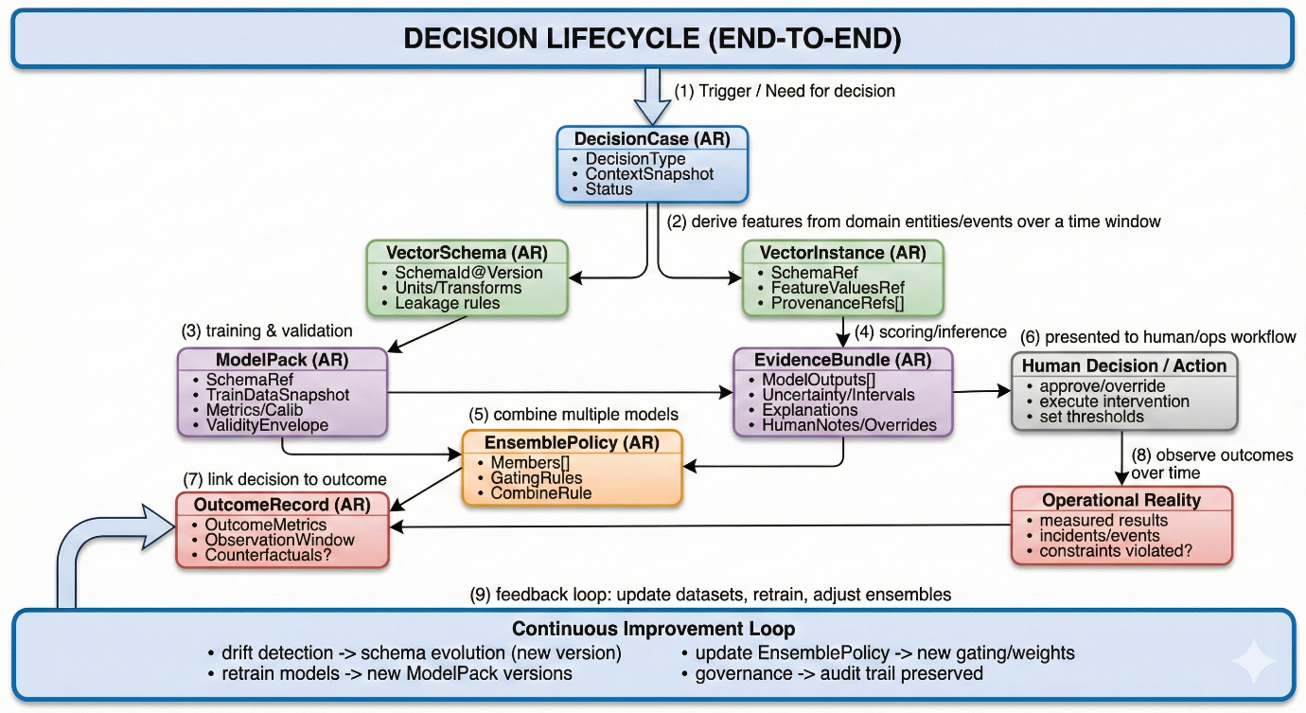

Appendix F - References and supporting notes
Include here any public references and any references requested by Florey can be placed here.
Domain-Driven Design (DDD)
- ThoughtWorks – Domain-Driven Design in 10 Minutes (Part 1 & 2)
https://www.thoughtworks.com/insights/blog/evolutionary-architecture/domain-driven-design-in-10-minutes-part-one
https://www.thoughtworks.com/en-au/insights/blog/evolutionary-architecture/domain-driven-design-part-two
Knowledge Graphs & Grounded GenAI
- Neo4j – What is GraphRAG (Retrieval-Augmented Generation)
https://neo4j.com/blog/genai/what-is-graphrag/
- Neo4j Customer Story – Enxchange
https://neo4j.com/customer-stories/enxchange/
Visualisation & Tooling
- Neo4j Video – Building Knowledge Graphs for GenAI
https://youtu.be/ZsR_BbBsA6I

Closing Statement
This architecture keeps engineering systems coherent by making domain semantics, decisions, and evidence explicit. It is DDD-first, tool-agnostic, and designed to support long-lived, auditable engineering projects where analytics and ML must remain trustworthy under continual change.

